Task on Jenkins-02
- Configure 2 slave machines in the Jenkins master.
Launched 3instance Maste,slave1 and slave2
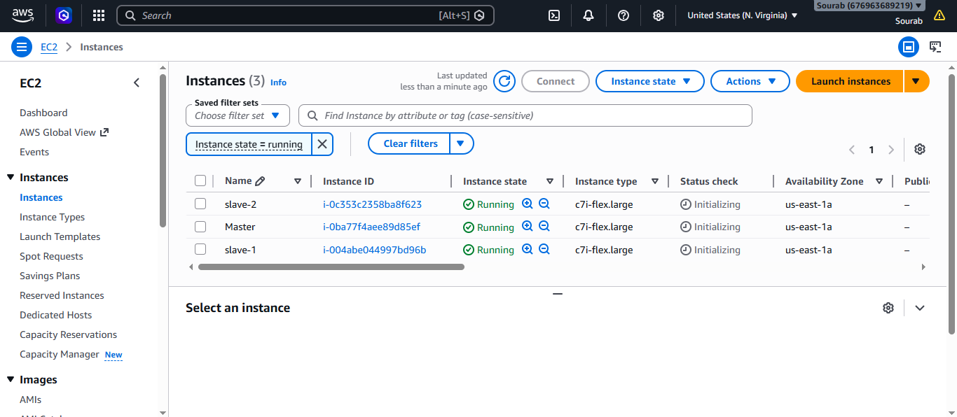
Installed Jenkins on master
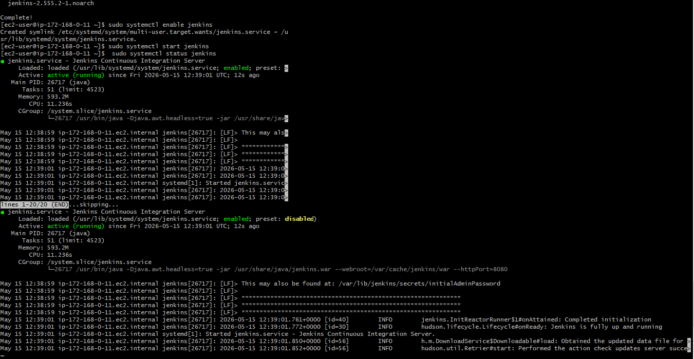
Installed Java on both Slave1 & Slave2
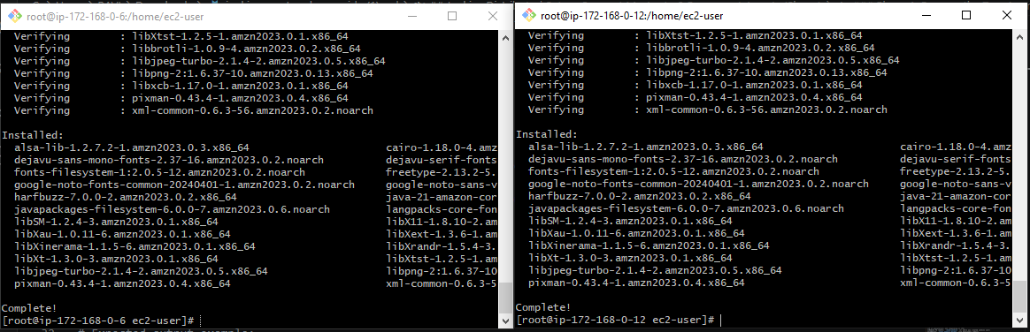
Create jenkins user
Create .ssh directory for jenkins user
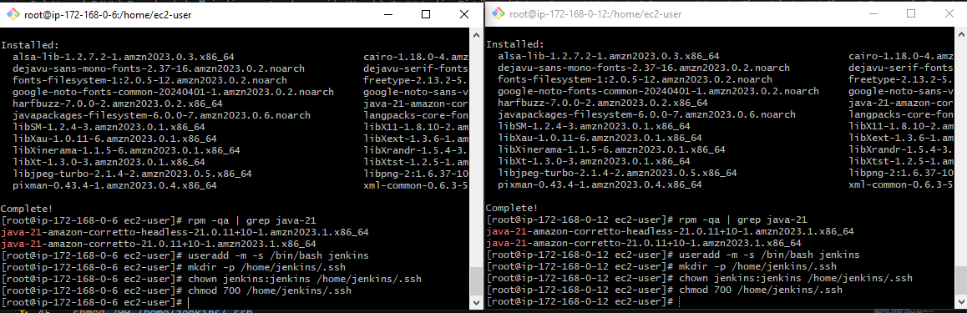
Prepare the Jenkins Controller (Master) – we need to do in Jenkins-
master server
Ensure the 'jenkins' user exists
# The Jenkins RPM package normally creates this user automatically.
# This command checks and creates it only if missing.
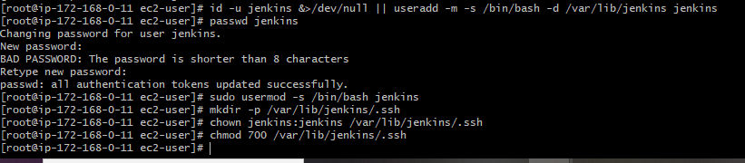
Now switch to Jenkins user → Navigate to .ssh directory
Generate RSA key pair
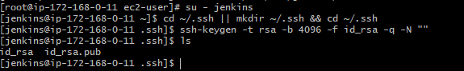
Set correct permissions
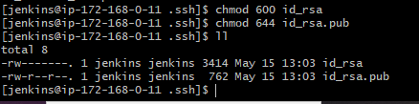
Display the public key (you will need it for slaves) → exit back to root
Public key: `/var/lib/jenkins/.ssh/id_rsa.pub`
Private key: `/var/lib/jenkins/.ssh/id_rsa
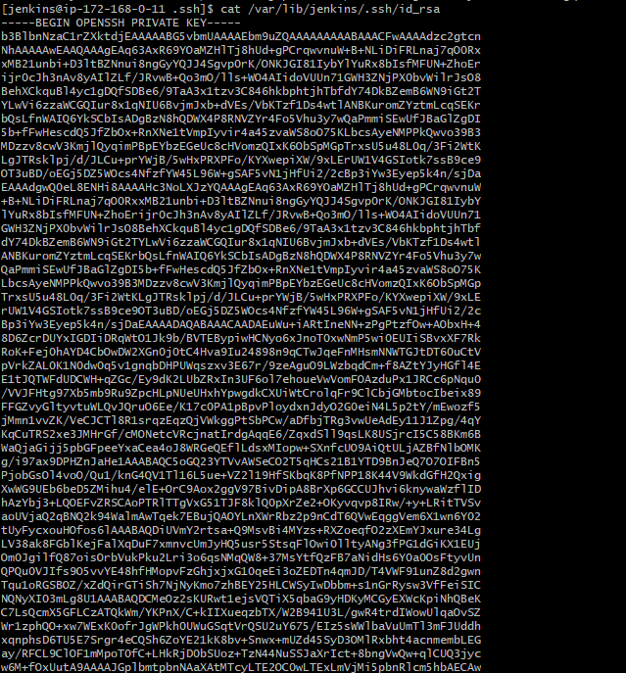
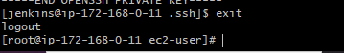
Copy the Public Key to Both Agents
In both slave1 & slave2
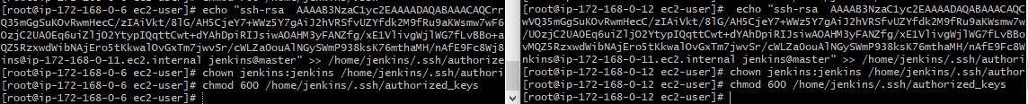
Add Agents' Host Keys to known hosts
Go to Jenkins server
Slave-1&Slave-2
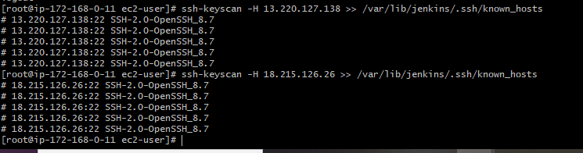
Fix ownership and permissions
Test Password-less SSH Connectivity (From Master to Slave Machines)
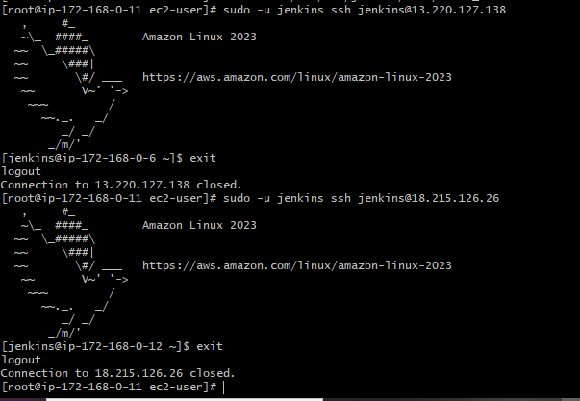
We are able to login to Jenkins
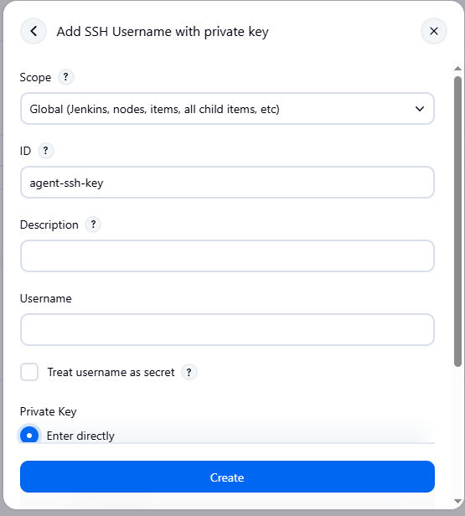
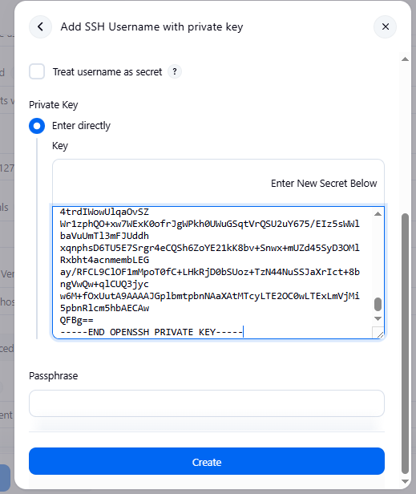
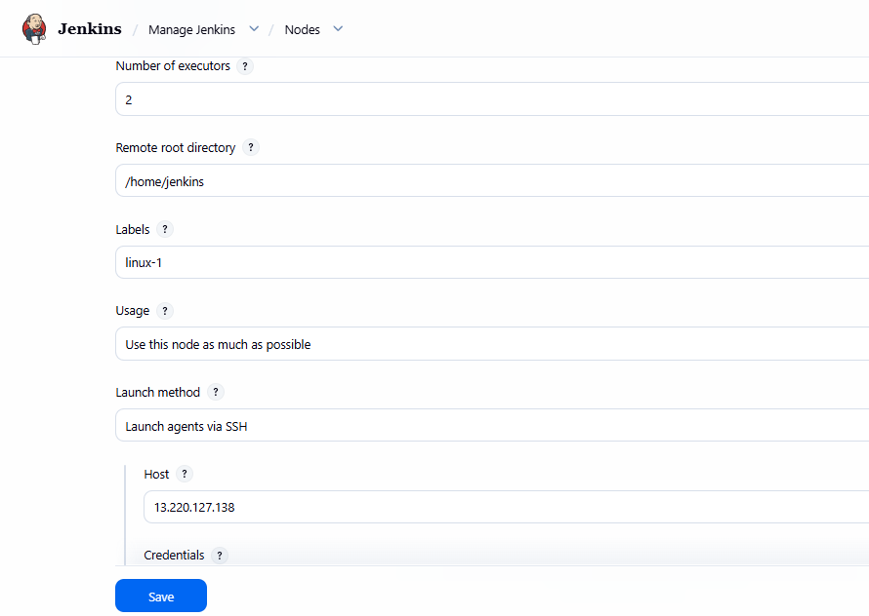
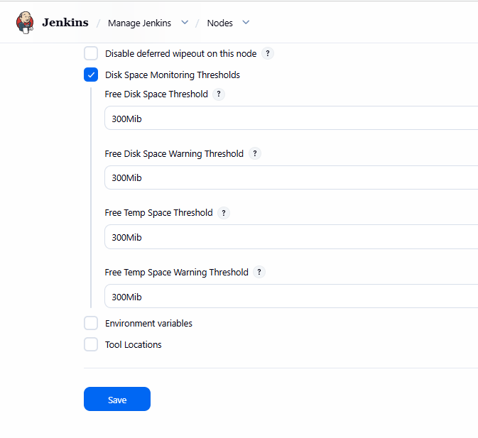
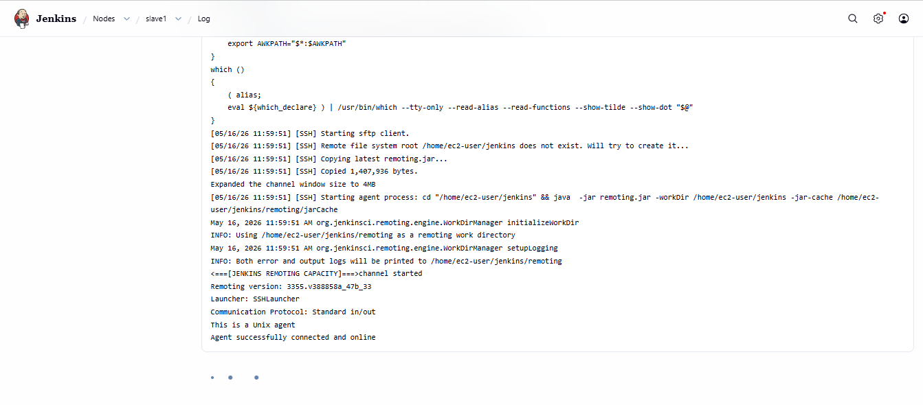
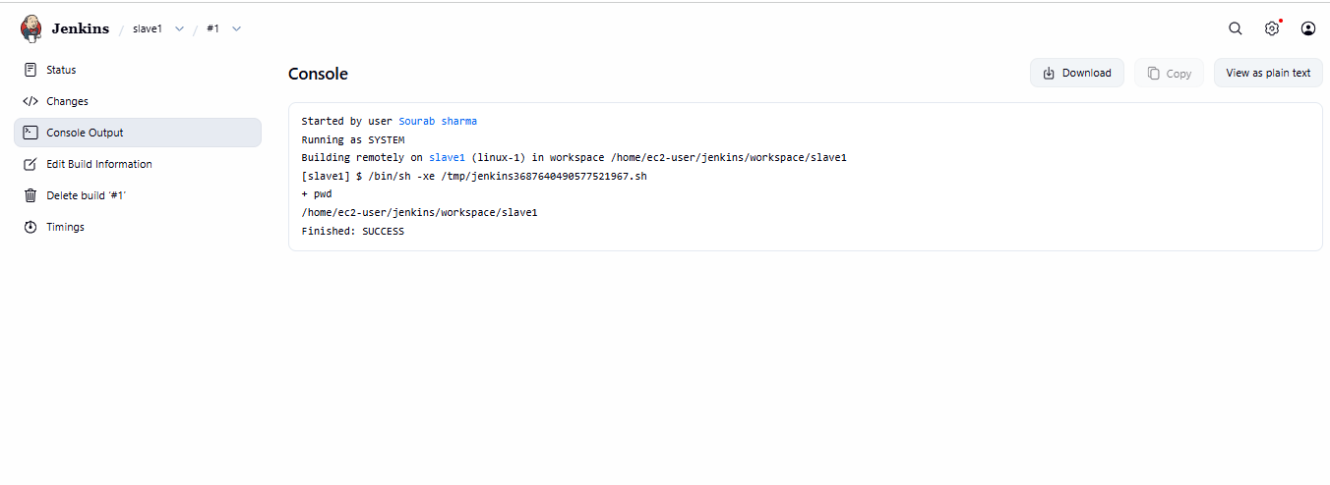
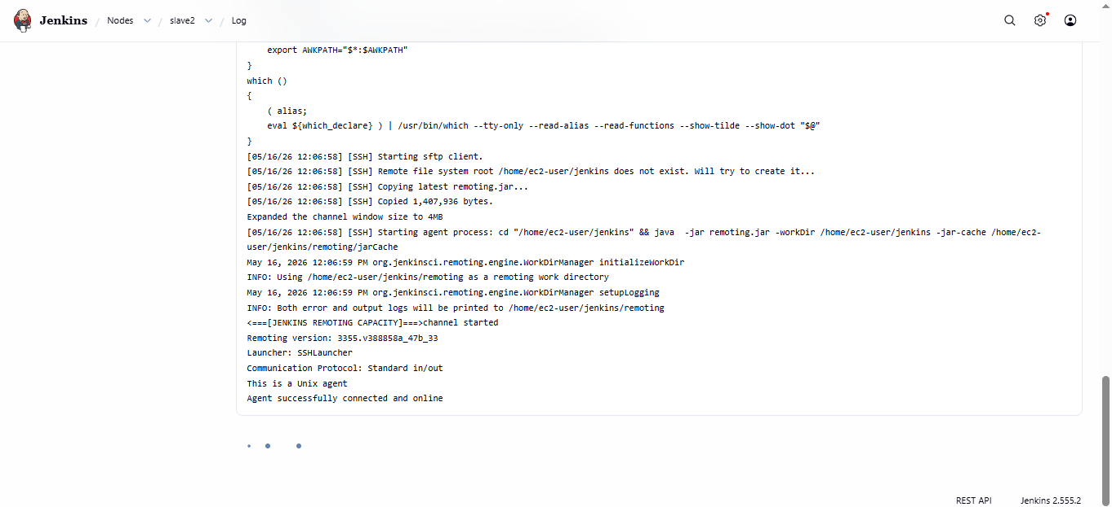
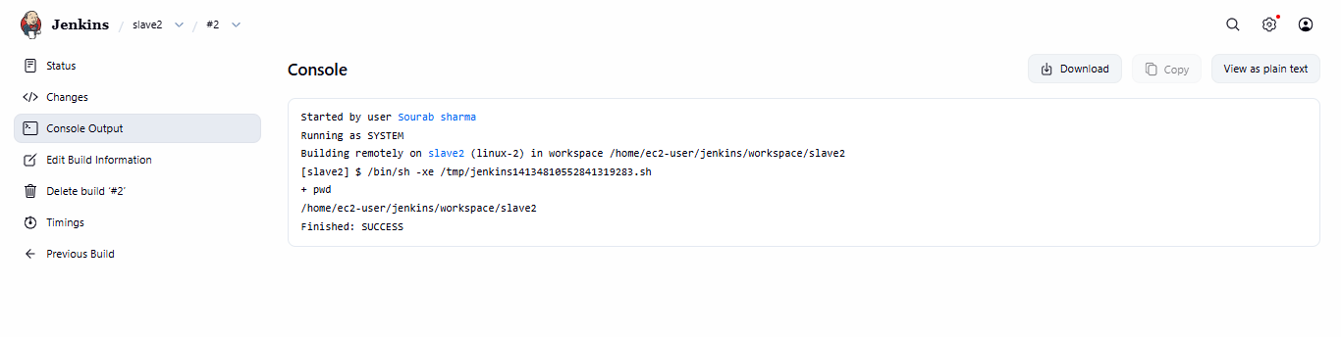

- Configure webhooks to the Jenkins job.
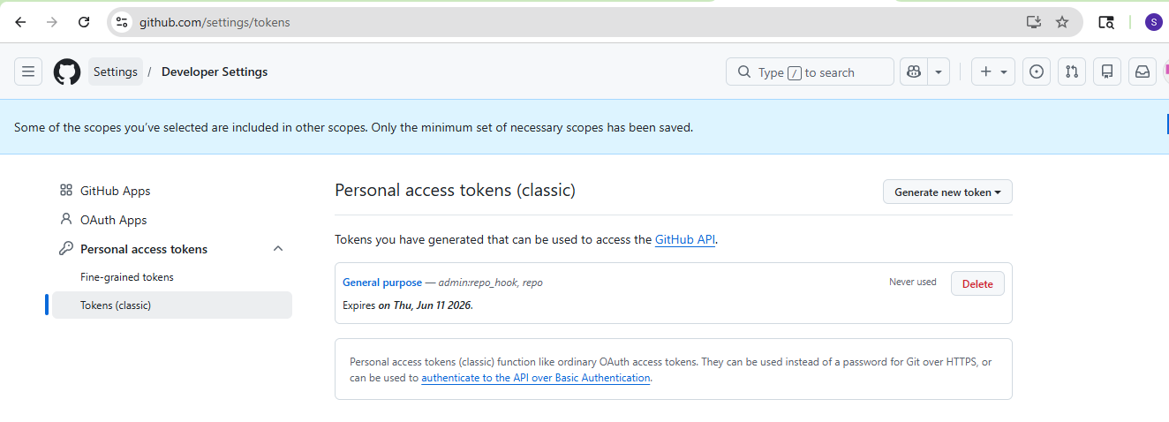
Created a new item in Jenkins with webhooks name:
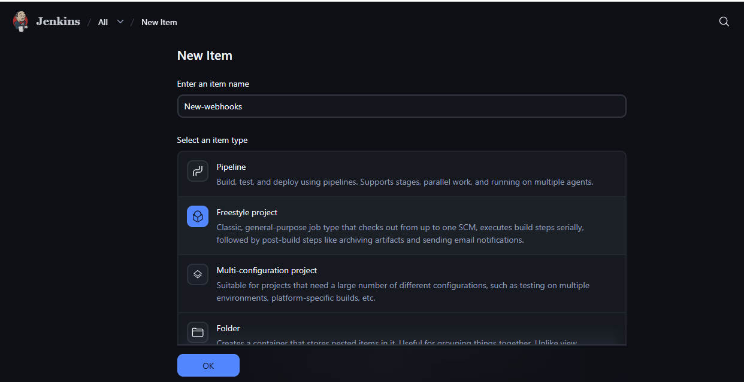
Added a private repo and then added credential option to it:
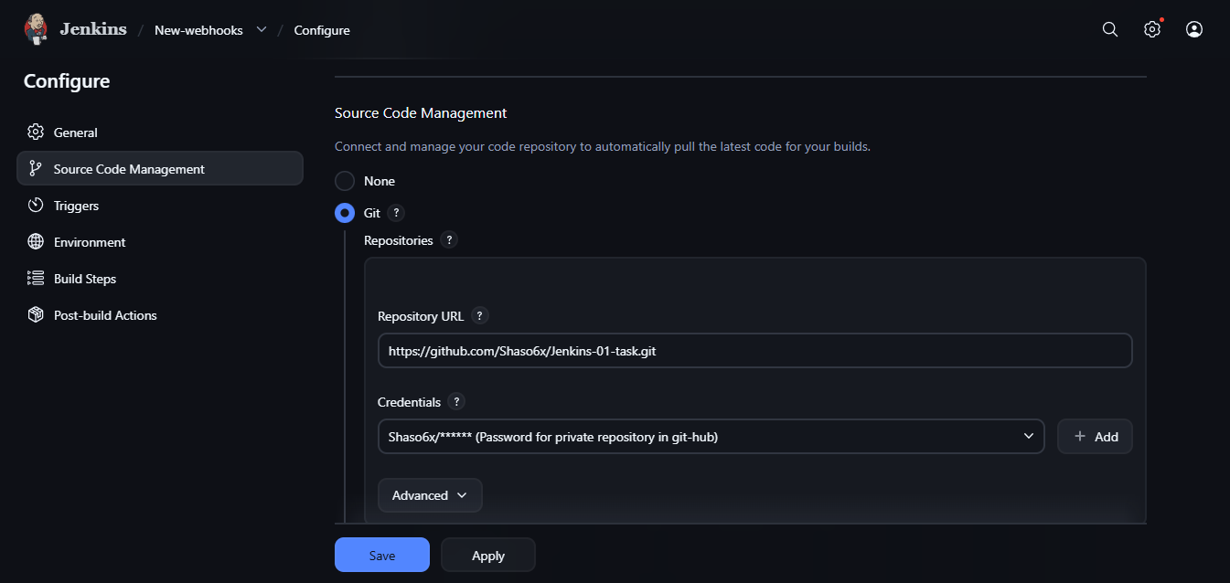
Then select the below trigger option:
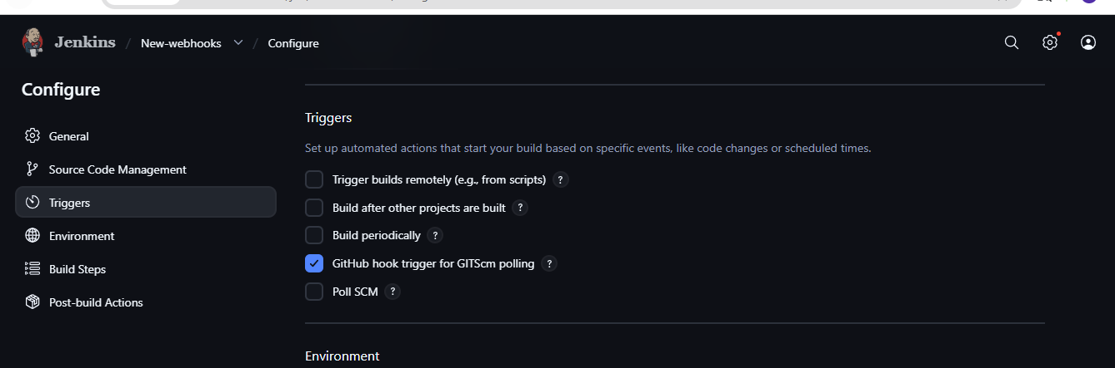
Created a new webhook option in the private repo with the following settings in it:
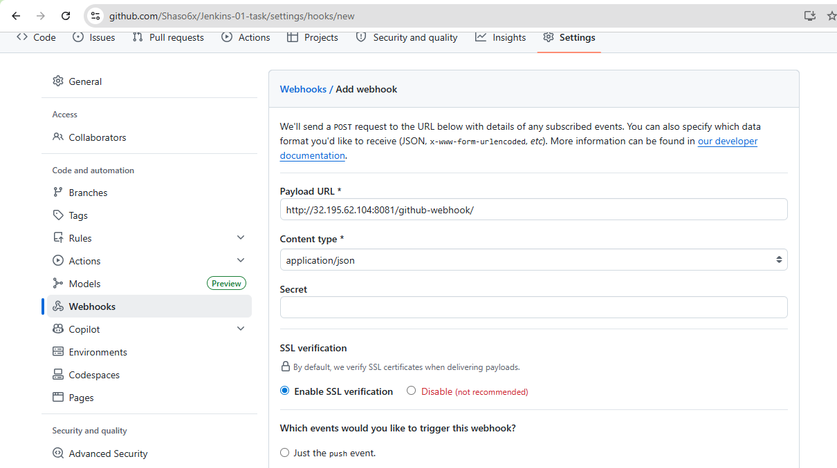 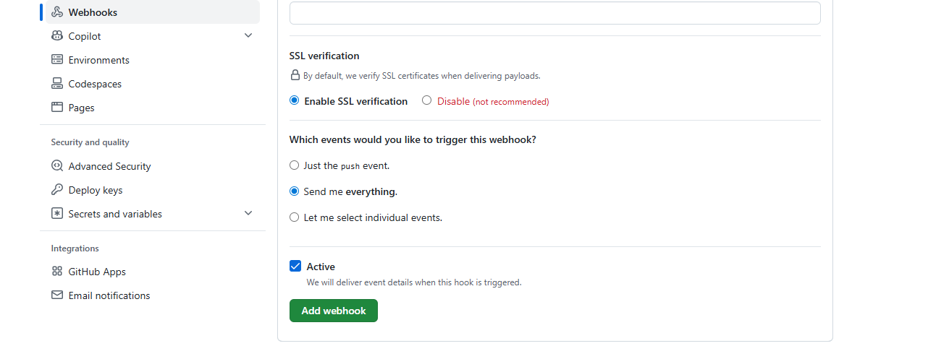
Made changes in the repo file:
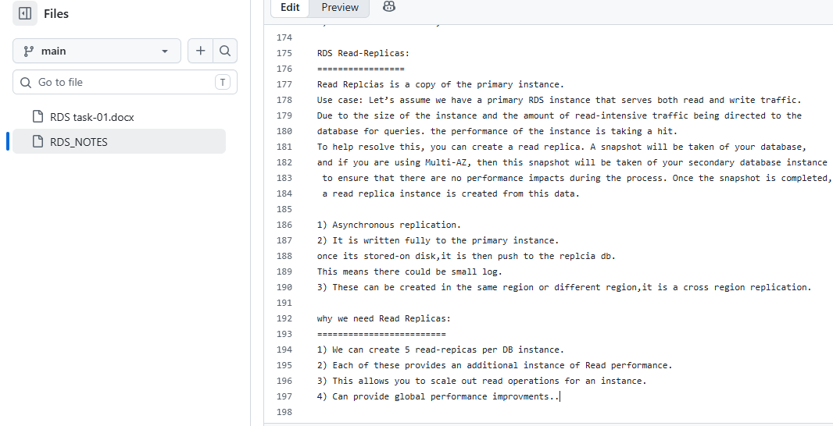
Webhook got build triggered when the label was removed as java and then kept it empty: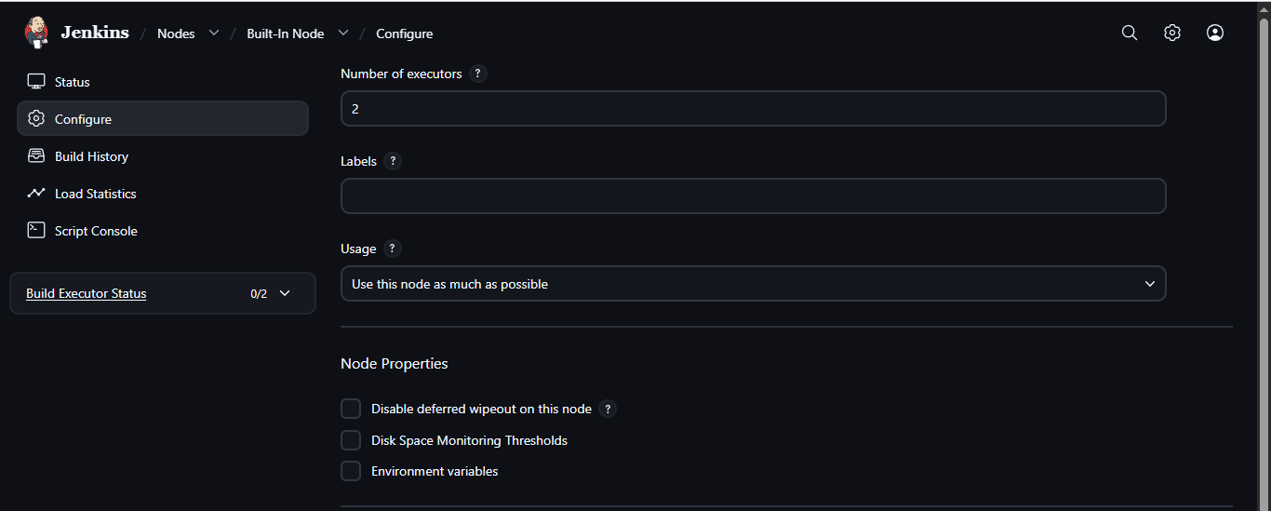
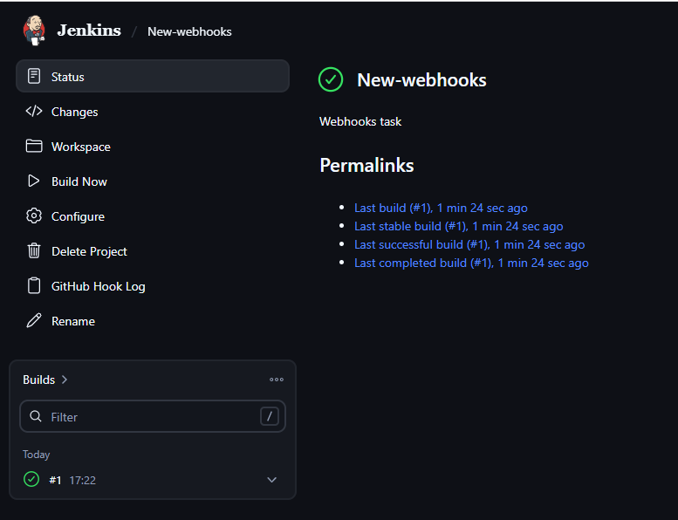
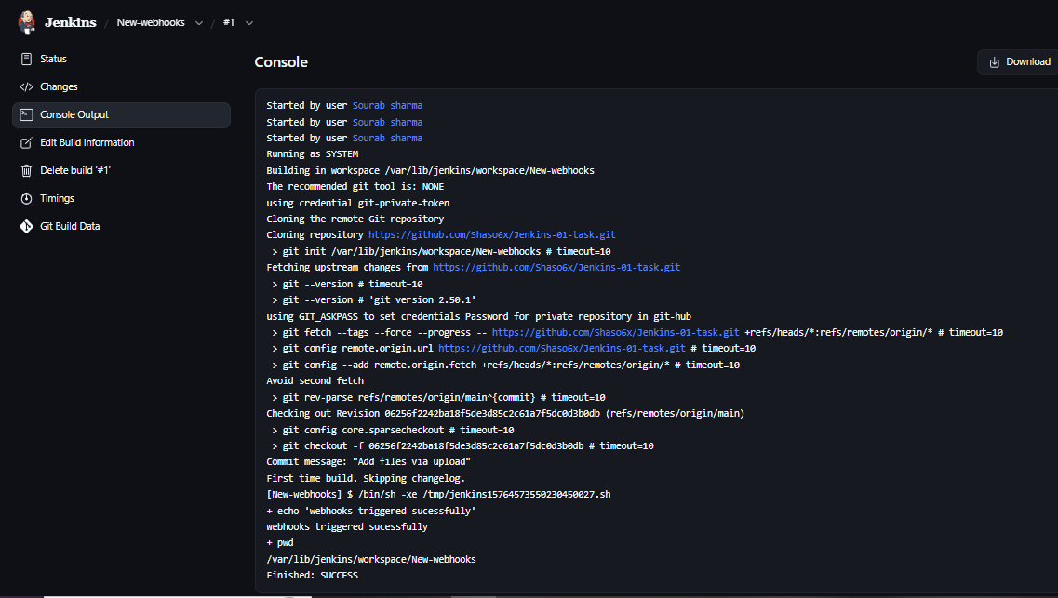
- Configure Poll SCM and Build Periodically options in the Jenkins job.
Create a new item with poll scm name and then when you see the configure make the below changes:
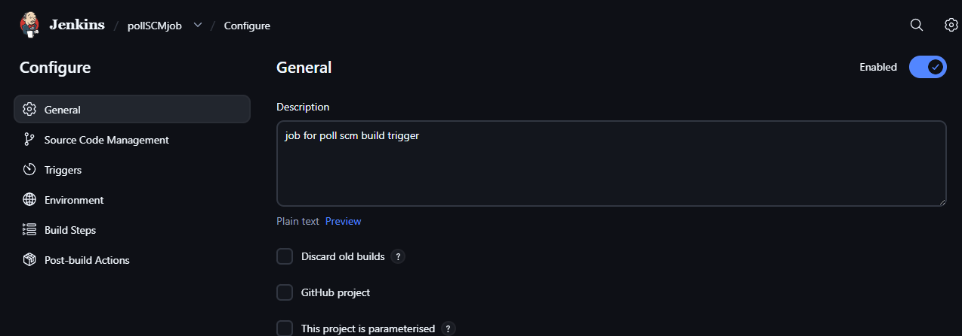 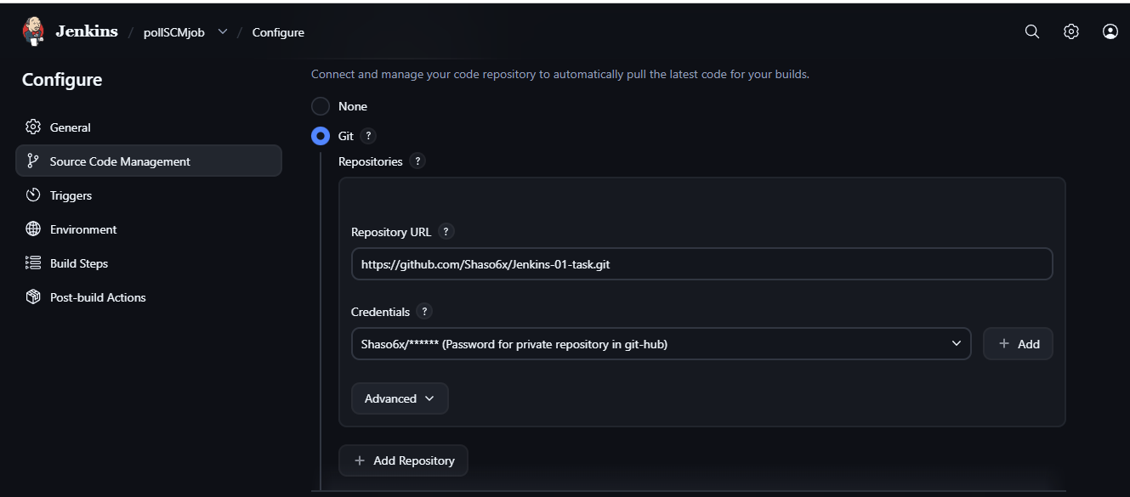 And we have scheduled it to run every minute every hour every day for testing It means if there is any change in our github repo then the job will run then click on save it
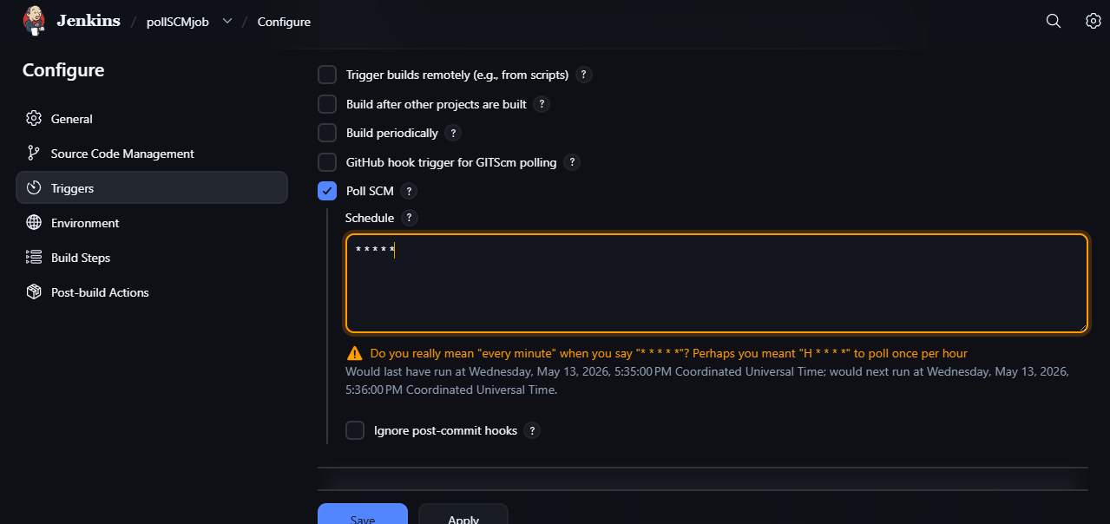
Build got trigger as we made changes in the repo of git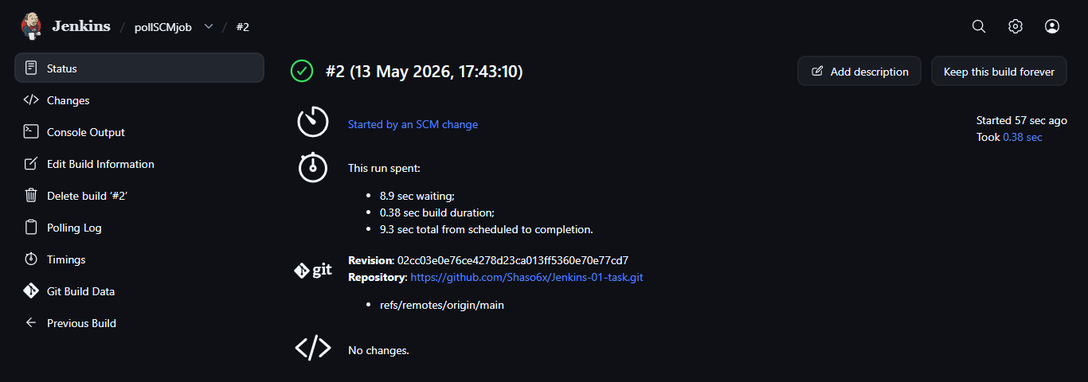 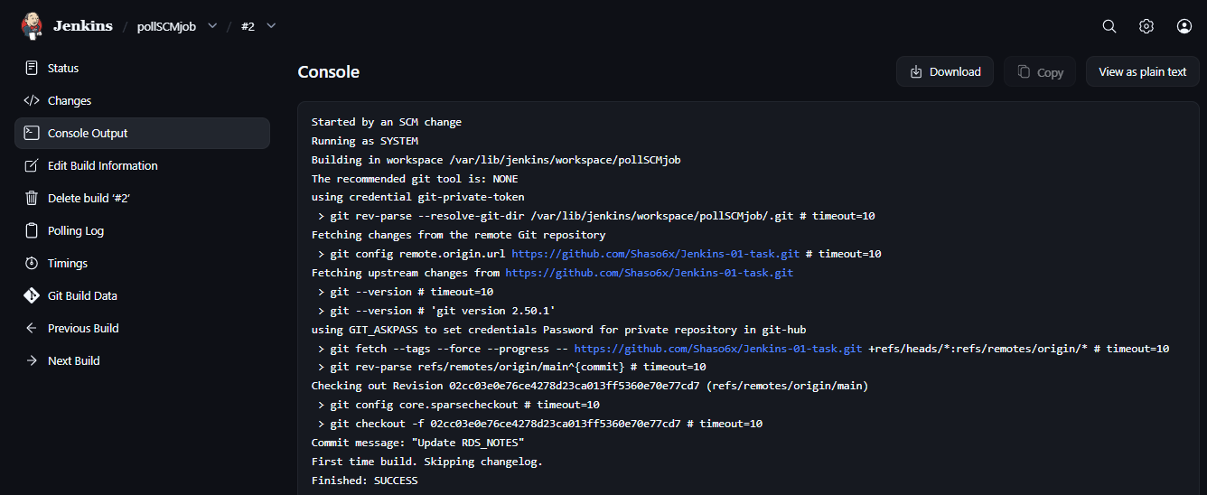
Build periodically as shown below:
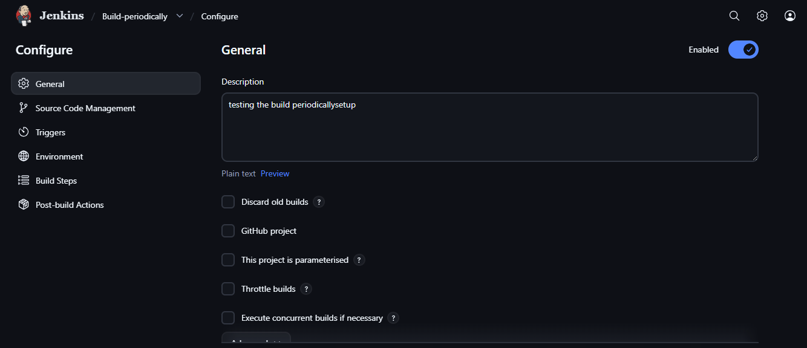 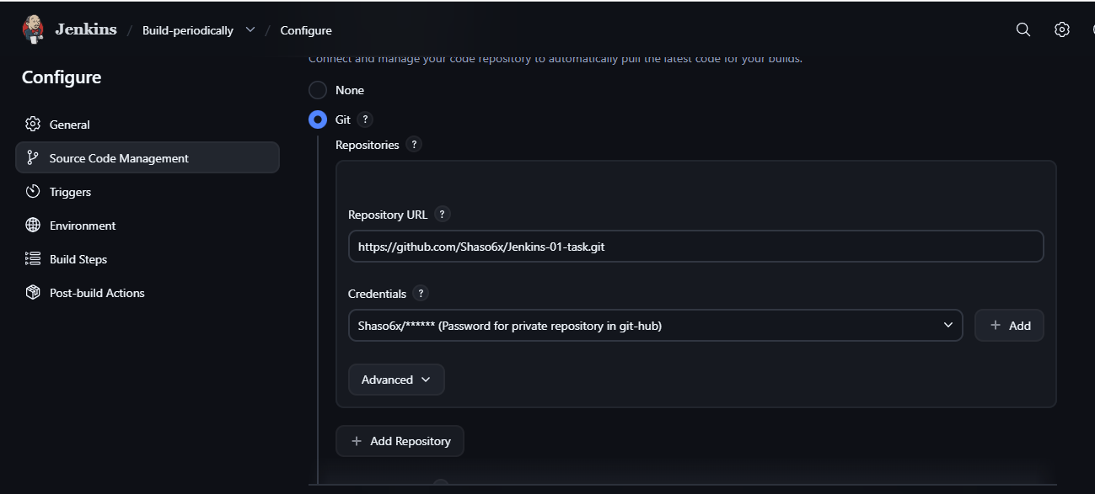 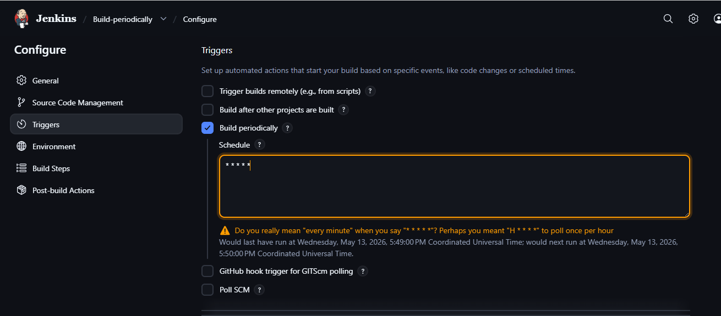
Automatically it started building:
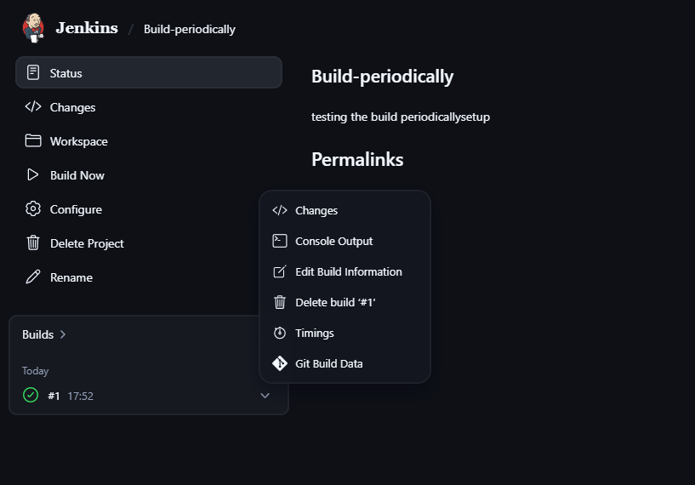 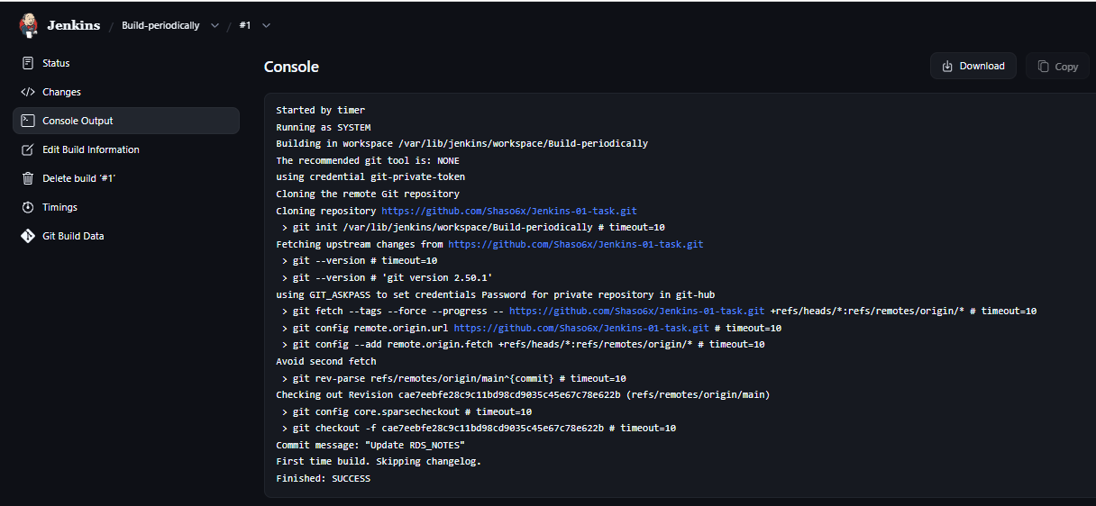
- Take a backup of the Jenkins server using a bash-script.
Connected to the ec2 instance and then followed the below commands shown in the image with the help of ChatGPT:
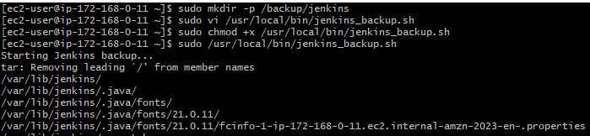
Followed the command as shown in ChatGPT steps and bash script to:
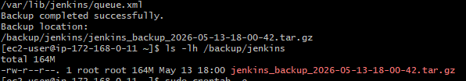
#!/bin/bash
# Variables
BACKUP_DIR="/backup/jenkins"
JENKINS_HOME="/var/lib/jenkins"
DATE=$(date +%F-%H-%M-%S)
# Backup filename
BACKUP_FILE="jenkins_backup_$DATE.tar.gz"
echo "Starting Jenkins backup..."
# Create backup
tar -czvf $BACKUP_DIR/$BACKUP_FILE $JENKINS_HOME
echo "Backup completed successfully."
echo "Backup location:"
echo "$BACKUP_DIR/$BACKUP_FILE"
- Take a backup of Jenkins using the Thin Backup plugin.
Installed the new thinbackup plugin in Jenkins as shown in the below image:
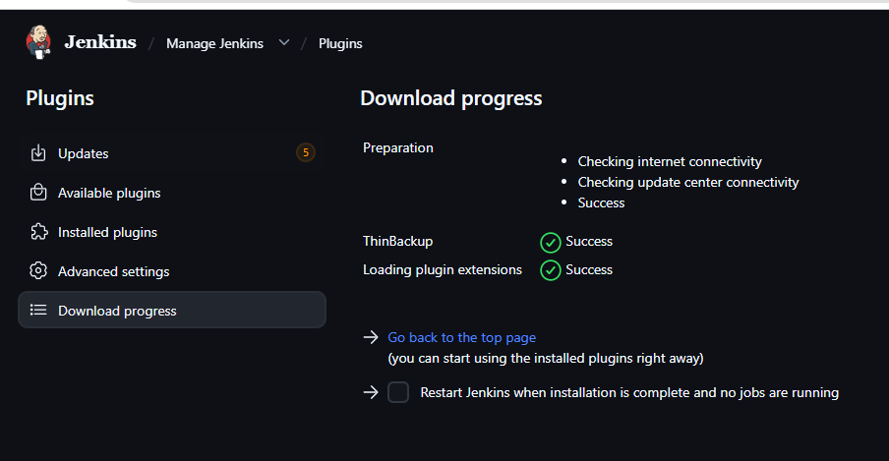
Then click on manage Jenkins and then click on thin backup as shown below:
To get the backup we need to configure the details In Manage Jenkins→ System→ Thin Backup Configurations → Details(Like Path and schedule and how many backups u need)→Save
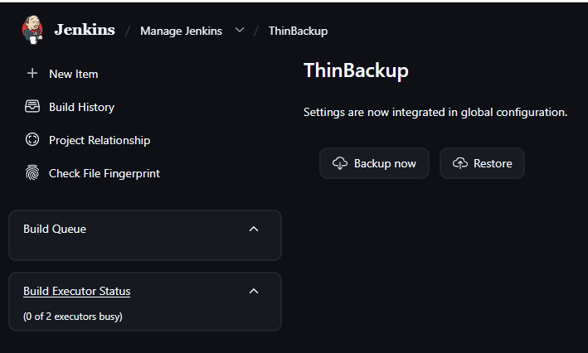
{Zero files showing in the cli need to check tomorrow}.
- Set up a new Jenkins server and restore the backup taken in task 4.
Created a new instance and then connected to it and then installed Java in it:
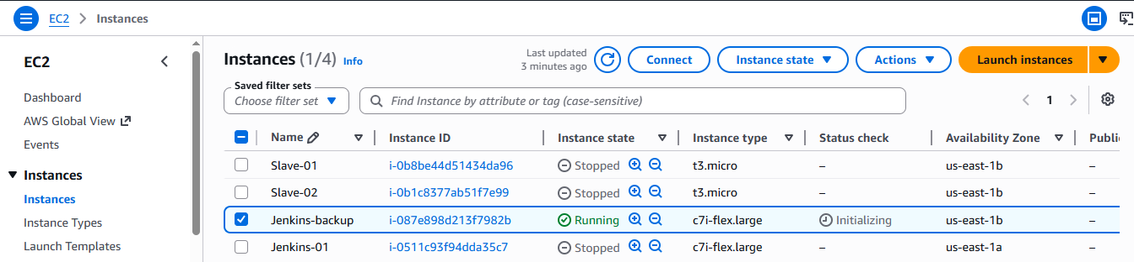
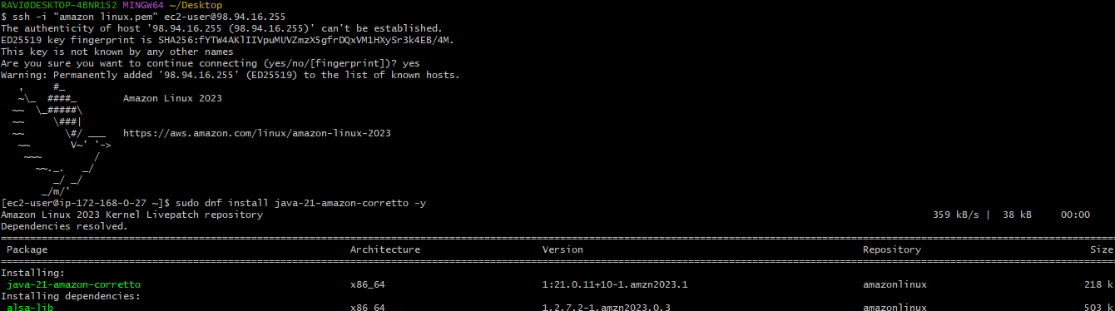
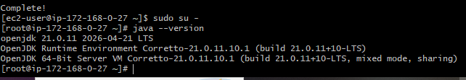
Installed Jenkins with the following commands:
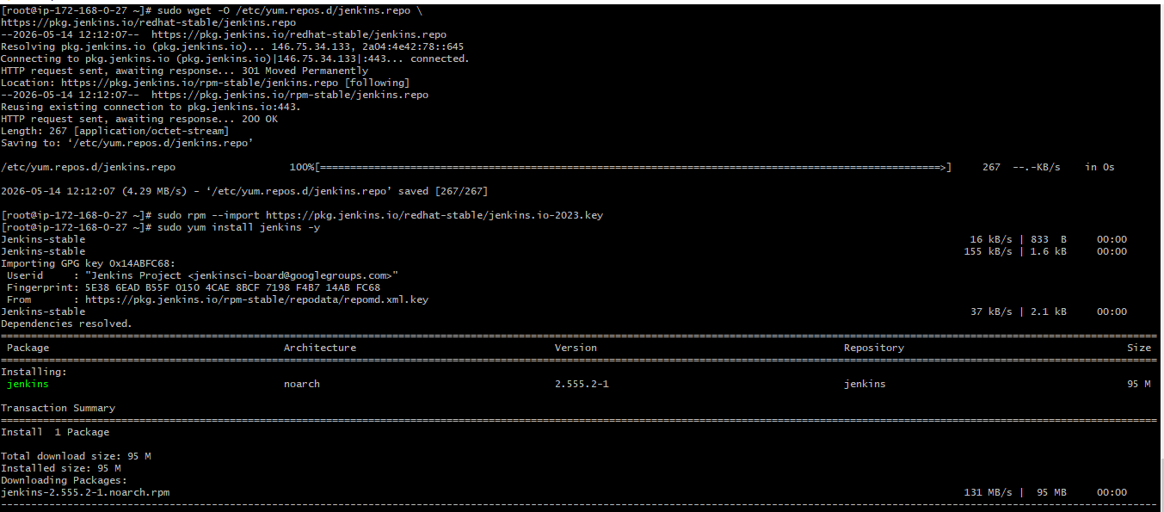
Copied the pem.key in the instance without going into any folder/directory and then give permission to pemkey and then execute the below shown command in the old server:
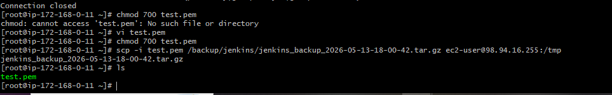
Then follow the below commands in the new server to get the backup from the old server:
